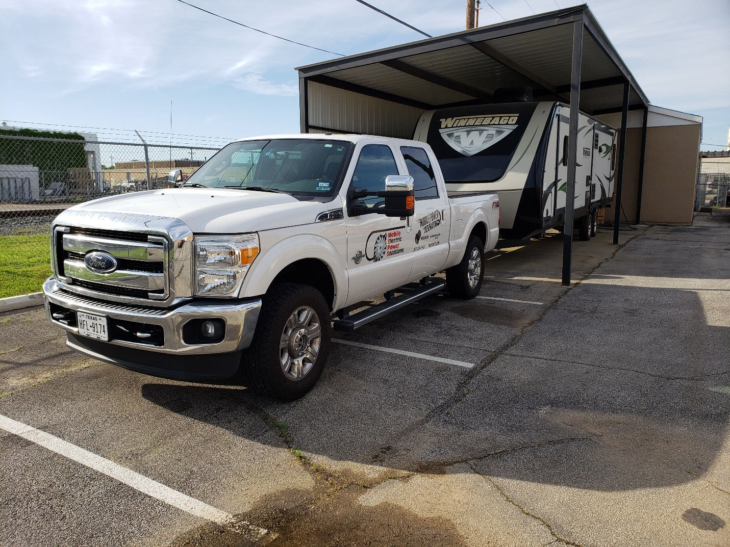

This is where we store our demo Travel Trailer that is a off grid dream. With the truck attached, as shown all loads can be run simultaneously (50 amps). With the vehicle engine off the existing battery can run 2/3 of the load for lose to an hour or the bedroom air conditioner for about 2 hours (add a battery and this goes to about 4 hours). With the vehicle hook up (electrically) and engine off the vehicle will start at a preset level of battery and recharge the battery while continuing to run the load. The air conditioning load is about 1600 watts and our battery charger is capable of 3300 watts into the battery. The battery can charge to its set point within an hour and the vehicle shuts down and waits for the next discharge point.

The advantages of this system:

* When vehicle is running it is running that loads and using the available power to recharge the batteries.
* When camped off grid the vehicle can be use to run to the store and the air-conditioner continues to keep the trailer cool.
* With the vehicle electrical connected to the trailer you can sleep cool all night and will likely not hear the vehicle start and stop when charging.
* The vehicle engine is quite fuel efficient an with a full tank to begin you will likely run our of fresh water and grey and black water capacity before fuel become an issue.

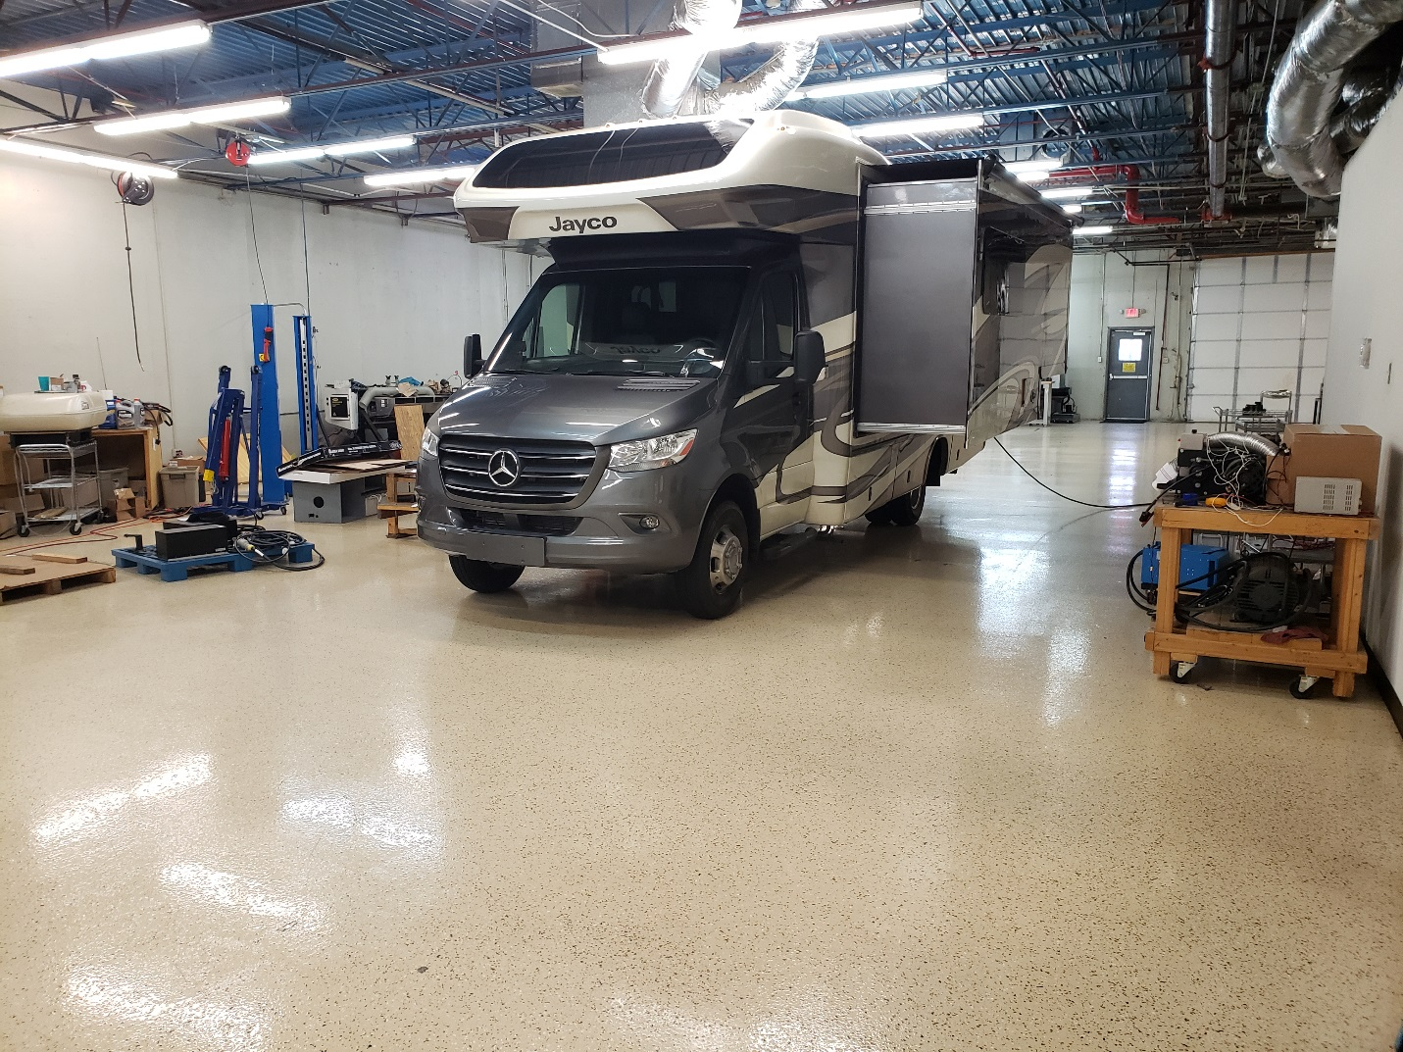

This is where we store our demo Sprinter RV and where we park it for improvements. This RV is a boondocking dream with the MEPS system and 400 AH of battery capacity in the generator space. The air conditioner is about 1500 watts and typically will run 50% of the time. Our battery and load capacity is 6000 watts when engine is running. Our charging capacity is 3300 watts. This uses 75% of our capacity.

The advantages of this system:

* No loud, polluting and fuel hog generator to run all night to power your air conditioner
* A quiet fuel-efficient engine that only runs (automatically) when your battery needs recharging probably less than 2 hours for a full night of air conditioning.
* Fits where generator was previously mounted
* Very low maintenance and always starts when you want to use it.
* Hook it to your house for emergency power.